**what is javascript ?**

javascript is a client side scripting language

javascript is used to load on browser

javasript is a case-sensitive language

eg: function(),getEmentById()

javascript is is used as programming language.

a)variable

b)operator

c)datatype

d)function

e)object

f)array

g)string

h)condition, loop

javascript demand in IT industry

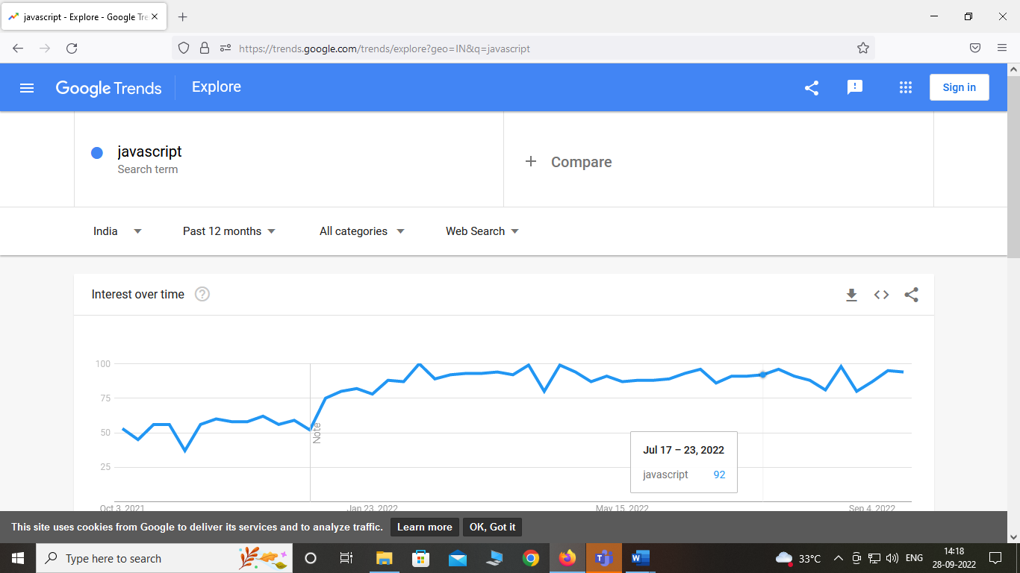

Javascript is used for load validation in form

Javascript is used to apply loader

Javascript is use to make calculator

Javascript is used to block user or block content on website

Javascript is used to load slider in website

Javascript is fast load data on browser.

Javascript is used to store data in cookie.

Javascript is used to store a temporary information on browser.

Javascript are used to regular expression for validate user data from user form.

Javascript is called <body> and <head> both.

Javascript is used to called inside of <script> tag

Javascript file extention is .js

**Advantages of JavaScript**

* Speed. Since JavaScript is an 'interpreted' language, it reduces the time required by other programming languages like Java for compilation. ...
* Simplicity. JavaScript is easy to understand and learn. ...
* Popularity. ...
* Interoperability. ...
* Server Load. ...
* Rich Interfaces. ...
* Extended Functionality. ...
* Versatility.

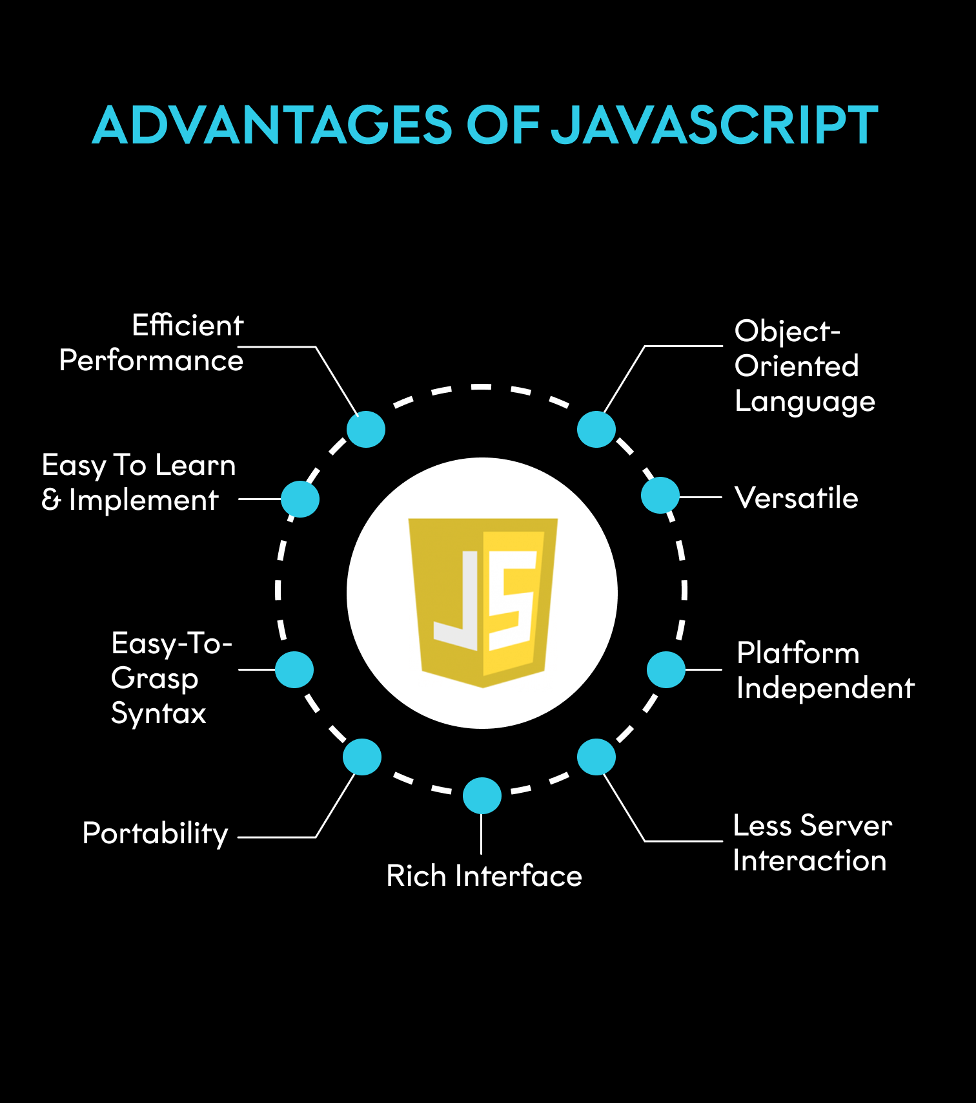

Javascript is used to set behaviour of your applications

Javascript called :

Body

<body>

    <script type="text/javascript">

        alert('hi i just loading javascript just click on OK');

        window.location='https://www.google.com';

    </script>

</body>

Head

<head>

    <meta charset='utf-8'>

    <meta http-equiv='X-UA-Compatible' content='IE=edge'>

    <title>Page Title</title>

    <meta name='viewport' content='width=device-width, initial-scale=1'>

    <link rel='stylesheet' type='text/css' media='screen' href='main.css'>

    <script src='main.js'></script>

    <script type="text/javascript">

        alert('hi i just loading javascript just click on OK');

        window.location='https://www.google.com';

    </script>

</head>

Javascript called external file

external.js

alert('Hi i am just load flipkart please click on OK')

window.location='https://www.flipkart.com';

external.html

<!DOCTYPE html>

<html>

<head>

    <meta charset='utf-8'>

    <meta http-equiv='X-UA-Compatible' content='IE=edge'>

    <title>Page Title</title>

    <meta name='viewport' content='width=device-width, initial-scale=1'>

    <link rel='stylesheet' type='text/css' media='screen' href='main.css'>

    <script src='js/external_js.js'></script>

</head>

<body>

</body>

</html>

Javascript Debugging

Compiler : convert hightlevel language into low level language.

Interpereter: convert hightlevel language into low level language.

Javascript is a interprete based language.

Note : javascript is a programming language and debug inside of console

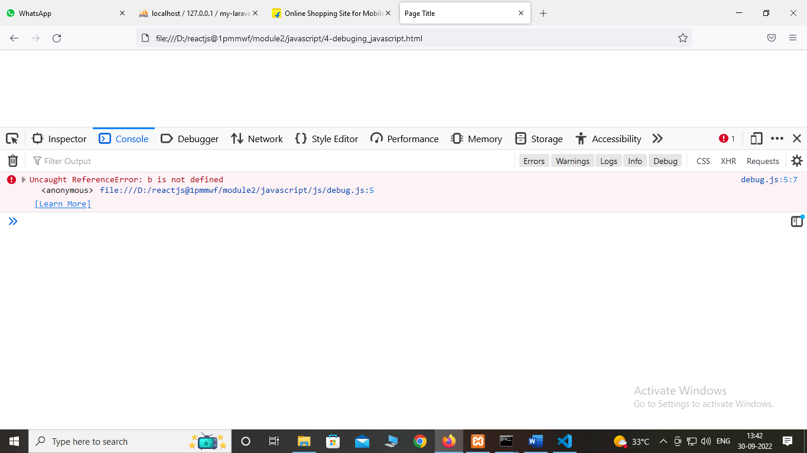

Javascript operator :

Javascript used as a programming language

Javascript operator is used to operand some actions there we used operator.

Types of operator :

1. Arithmetic operator

Eg: + , - , / , % , *

1. Assignment operator

Eg: = , +=, -=, %=, *= , /= etc

1. Comparison operator

Eg: ==, ===, !=, >,<,>=,<= , !== etc,

1. Logical operator

Eg: && and, or ||, !

1. Ternary operator

Eg: :?

1. Increment/decrement operator

Eg: ++,--

1. String concatenate operator

Eg: +

Javascript variable :

Javascript variable is just like a container where we store an information about data.

Or

Javascript is used to store information about a data i.e called variables.

How to defined variable

Eg: var a=10;

var b=””;

var c=10.65465;

var d=’my name is brijesh’;

var name;

var name=”brijesh”;

var ab=5421541215224521n;

eg: : let a=10;

let b=””;

let c=10.65465;

let d=’my name is brijesh’;

let name;

let name=”brijesh”;

let ab=5421541215224521n;

what is difference b/w var and let

var : var is used to defined global or access globally.

var a=10;

let: let is used to defined local or inside of function

let a=1265;

**Datatype :**

A datatype is values are stored inside of variables

Eg: var a=1321221; //number

var a=10; //number

var b=””; //string

var c=10.65465; //float

var d=’my name is brijesh’; //string

var name; //undefined

var name=”brijesh”; //string

var ab=5421541215224521n; //big integer

var employe={“name”:”Brijesh”} // object

var a=Symbol(5454);

Note : we check each variables of datatypes is with typeof() functions

<script>

var a=1321221;   //number

var ab=10;  //number

var b=""; //string

var c=10.65465; //number

var d='my name is brijesh';  //string

var jj;

var name1="brijesh";  //string

var abc=5421541215224521n;  //big integer

var employee={"name":"Brijesh","salary":78000,"age":31}  // object

var abcd=Symbol(5454); // number,string,object,symbol,bigInteger

var aaa=true;

document.write(typeof(a),"<br>");

document.write(typeof(ab),"<br>");

document.write(typeof(b),"<br>");

document.write(typeof(c),"<br>");

document.write(typeof(d),"<br>");

document.write(typeof(jj),"<br>");

document.write(typeof(name1),"<br>");

document.write(typeof(abc),"<br>");

document.write(typeof(employee),"<br>");

document.write(typeof(abcd),"<br>");

document.write(typeof(aaa),"<br>");

</script>

Javascript function :

Javascript function is a block of code i.e used to completed any task i.e called function.

Or

A function is a block of code or group of code i.e called function .

Types of function

1. User defined function

function test()

{

Statements;

}

Call a function

1. Pre defined function

Eg: document.write(), typeof() , parseInt() etc.

How to call a functions

1. Call by value
2. Call by refrence